CyberCafe CyberSafe Android Application Manual

# Introduction

The CyberCafe CyberSafe application is designed to ensure a safer internet environment for children. This manual explains the different features and functionalities of the application based on its interface and underlying code. We will review the various screens and their functionalities along with the code logic that drives them.

# 1. Home Screen

The home screen is the starting point of the application. It provides navigation options and access to various key functionalities such as the Hotline and Helpline submission forms. The user can access these through the hamburger menu on the top left side of the screen.

## Home Screen UI

The home screen, as shown above, displays the 'Cyber Safe CY' banner and contains navigation elements. It is built using the HomeFragment class in the code, where a WebView is used to load the main website.

# 2. Menu Navigation

The menu in this application provides navigation to various important forms, including the Hotline and Helpline. These forms are designed to report various cyber issues. The menu is a simple navigation drawer controlled by the MainActivity and DrawerLayout.

## Menu UI

In this screen, the menu provides options to navigate to Home, Hotline, and Helpline. The user can report cases by selecting the desired option.

# 3. Hotline and Helpline Forms

These forms allow users to submit cyber incidents. The form is built using a WebView that loads the forms from external URLs. It allows users to select the type of incident, submit personal details optionally, and complete a CAPTCHA for security.

## Hotline Form UI

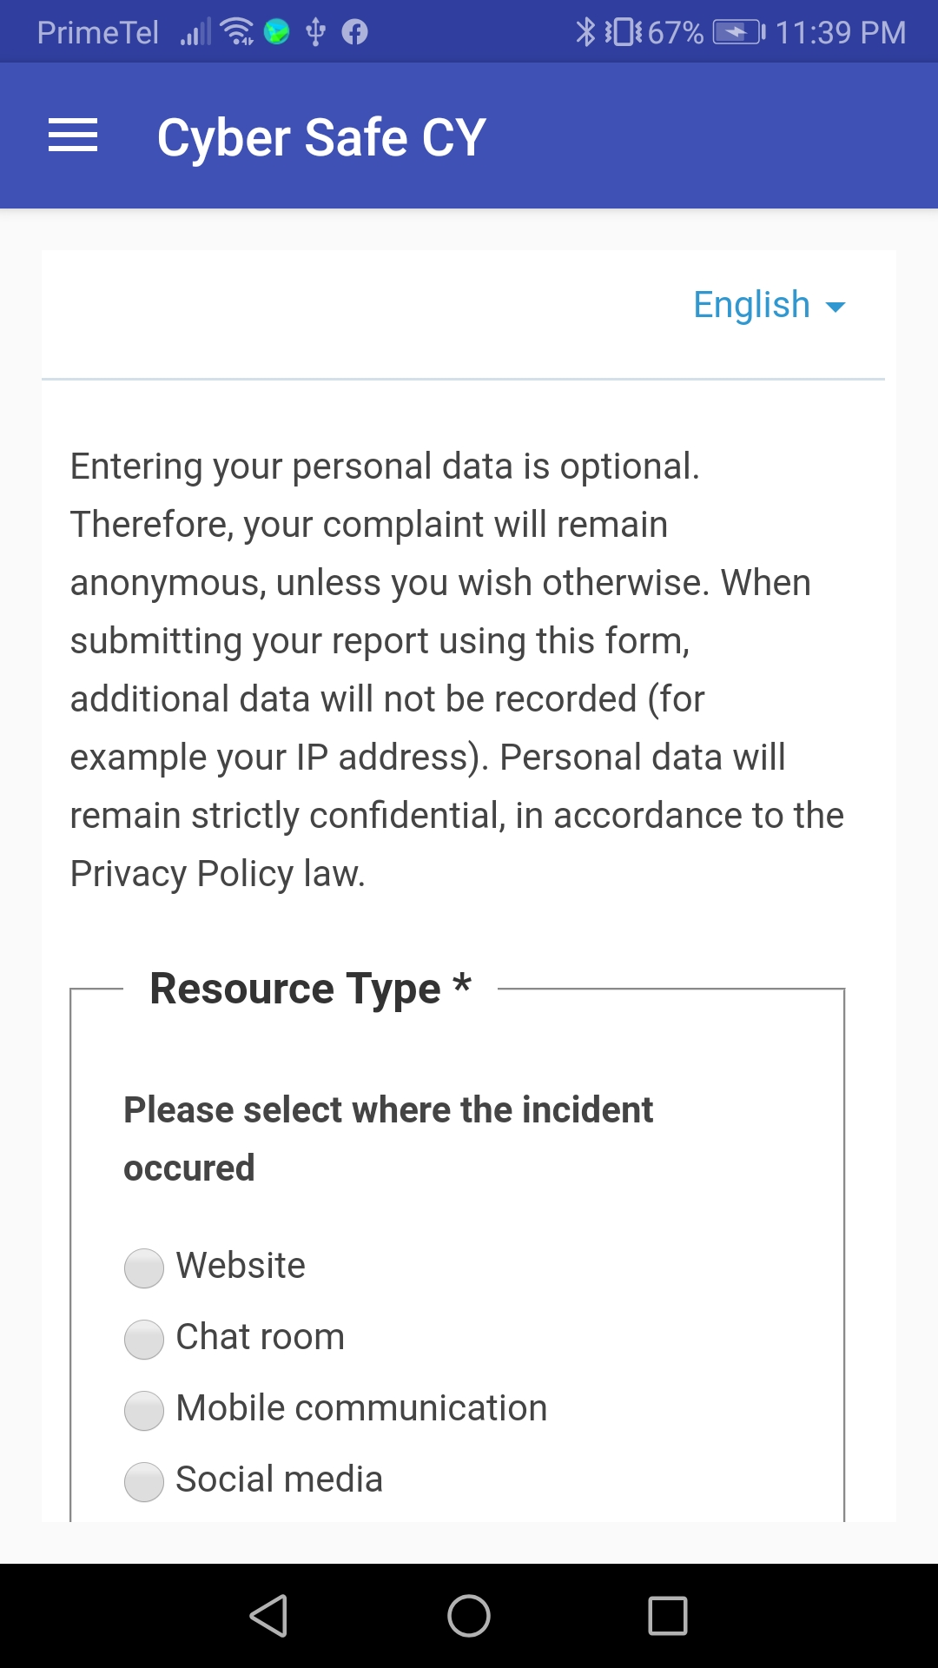

## Helpline Form UI

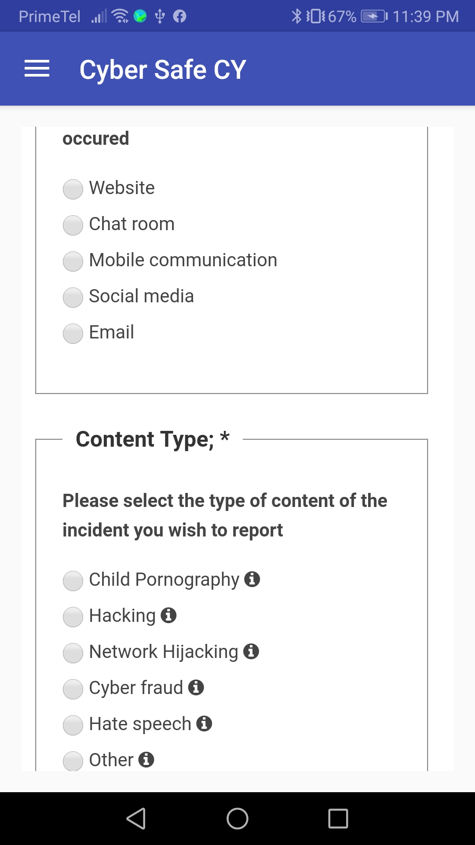

The Hotline and Helpline forms, as shown above, prompt the user to enter details about the incident. The forms offer multiple categories for the type of incident, such as hacking, fraud, and hate speech.

# 4. Form Submission

Upon filling the necessary fields, users can submit their case through the form by completing an authenticity check (CAPTCHA). The data will be processed according to the privacy policy, ensuring confidentiality.

## Form Submission UI

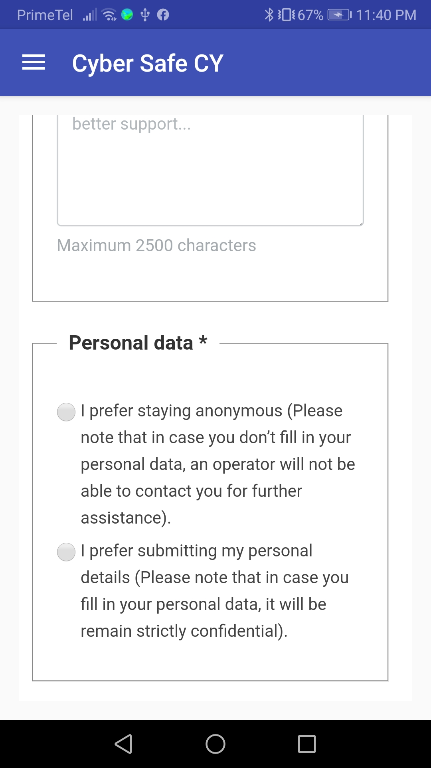

The submission process includes selecting the type of incident, optionally entering personal data, and passing the CAPTCHA check.